Homework #4

Webpage Report

Kim YungBok professor

Class: Web Programming (001)

절.대.웹.프.해 -Class #1, Team #10

13011133 김무영 Kim Muyoung

1801550 차성규 Cha Seong Kyu

18011588 하승원 Ha Seungwon

Contents

1. Introduction
   1. Topic decision
   2. Role Distribution
2. Ha Seungwon – PLAYERSUNKOWN BATTLEGROUNDS
3. Kim Muyoung – StarCraft
4. Cha Seong Kyu – League of Legends
5. Introduction

1.1 Topic Decision

At the very first meeting, of the semester, we had a little query of our hobbies.

What we had in common was playing computer games, otherwise developing programs. The topic decision for the final project was not difficult, that we would build a webpage which introduces computer games..

1.2 Role Distribution

Unlike other teams that submitted their pages in the 한국;.net, whose role distribution would be on the language of the program ( i.e. html, CSS, JavaScript). Normally this type of distribution would be great, if the team members would cooperate accordingly. However, judging from the previous team projects that we respectively had expectation was futile. Therefore, our team had decided to develop a web page of our favorite game each, then we would combine it together. In this way, even if one of the members drops out, or his cooperation is insufficient, the project could still be met to tis requirement.

1. Ha Seungwon – PLAYERSUNKOWN BATTLEGROUNDS

This chapter would describe the source codes of major features that are in the webpage. Before, the major contents of the page is video page, news, information.

Firstly, Video page shows YouTube videos of my favorite streamers & Youtubers. It starts with a trailer video of the game Battlegrounds, then follows the name of the streamer, one of the representing clips, and the URL link to the YouTube channel. Secondly, the news page contains the lastest news updates, from the official homepage of PLAYERSUNKOWN BATTLEGROUNDS. Finally, the information page is about the guns used in the game, that shows: type, Firing mode, Map, Spawn rate, Damage, Rate of fire, Bullet speed, Reload Duration, Range.

This report will show the major features used in creating this webpage.

The first feature is the navigation bar

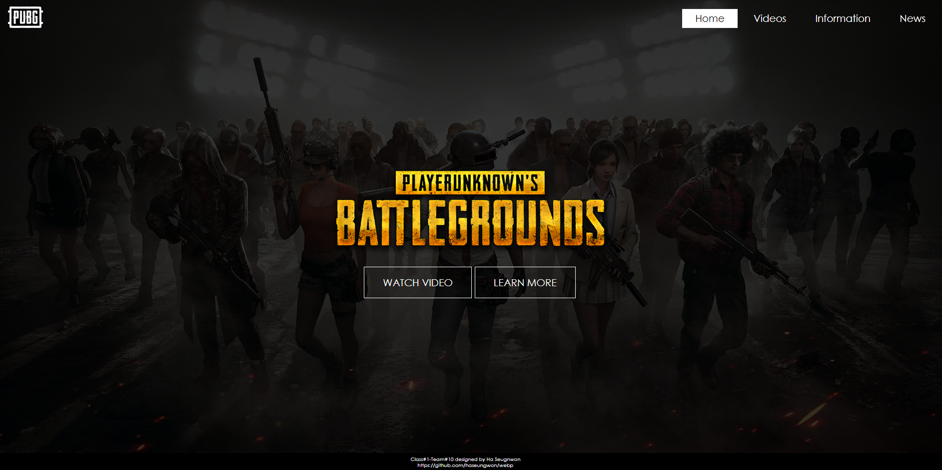

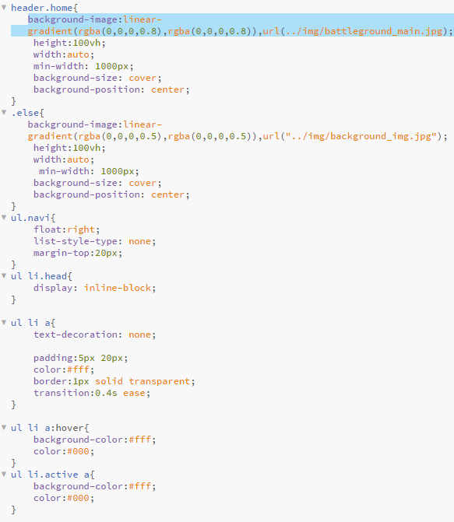

The basic CSS script is as shown above. The ul> tag has float property and no list-style-type, which removes the bullets, the <li>tag inside <ul>tag has a inline-block property. And the transition property makes the animation effect when the mouse hovers over it. Secondly, the transparency, rate makes an awesome effect on the background.

The Video page has <div> structure to make a layer structure for the webpage.

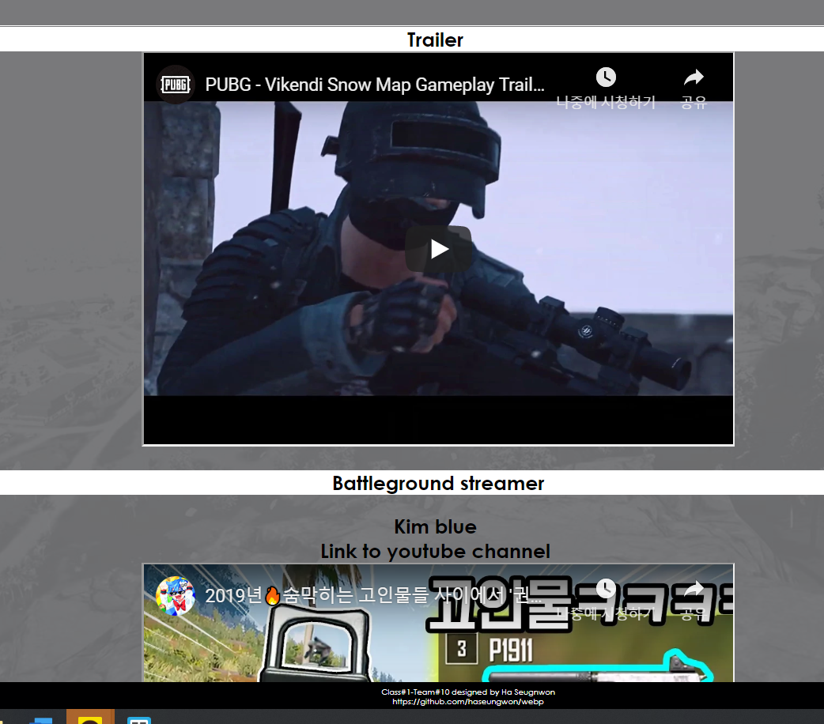

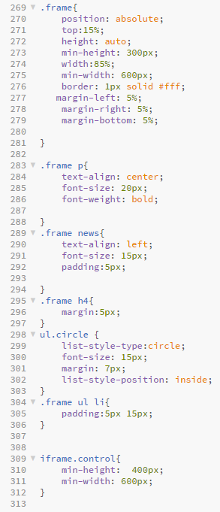

The frame class makes first layout for the webpage structure. These class is used in the News page. To make the video clip, and the image align at the center, the following method was used.



And the link to the YouTube channel the code is as follows.



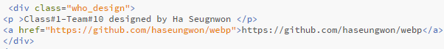

This <div>tag is differentiated, from the other <div>tag, by the class frame.

The News page uses jQuery to make a slide effect. So the flood of information in the html file, is hidden, which makes the web page look orderly, as well as allows the users to selectively show the wanted information

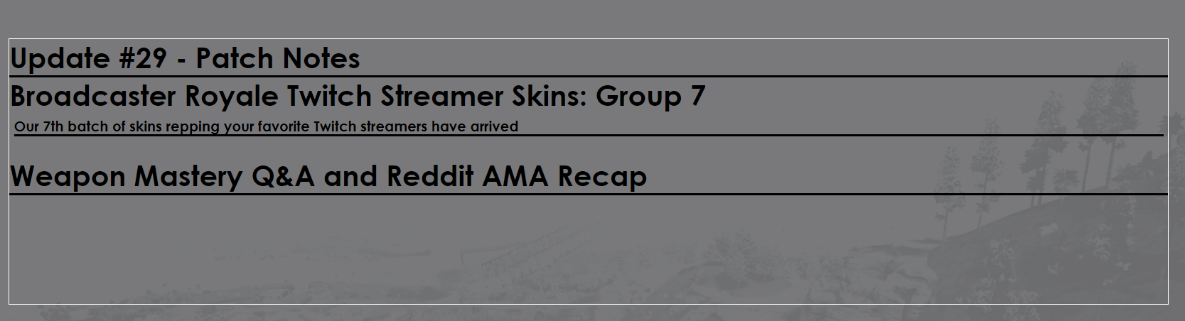

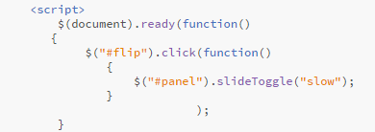

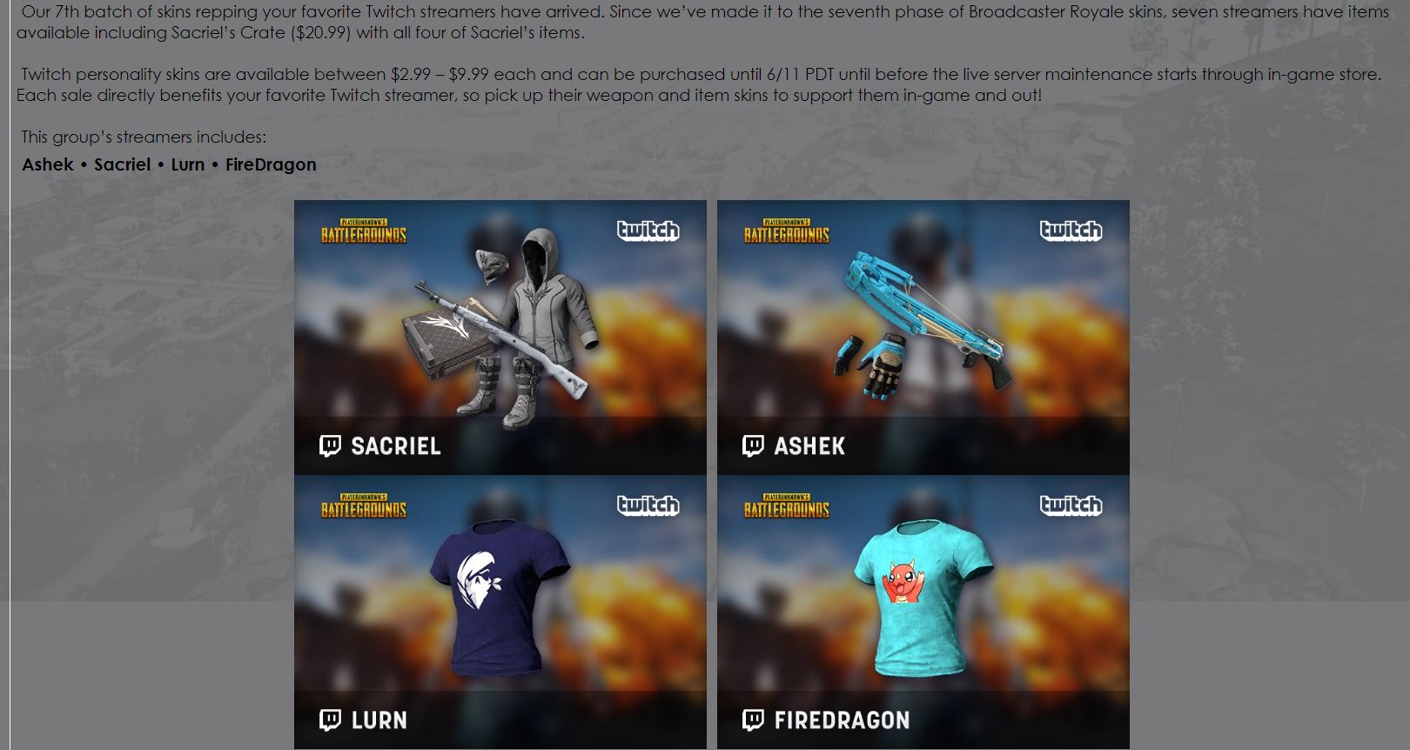

It is basically, means when the tag with the ‘flip’ id is clicked, the tag with ‘panel’ id, that is hidden from the start, is toggled to appear in the screen.

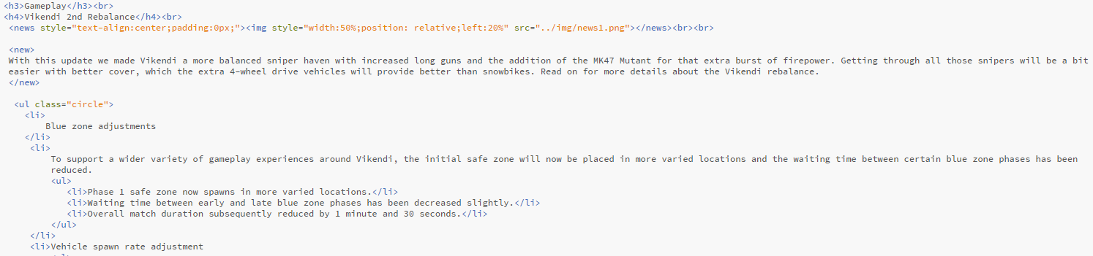

This type of html script has about 400 lines and in this way of keeping it ordered, makes it visually apleasing.

The information page begins with the following:

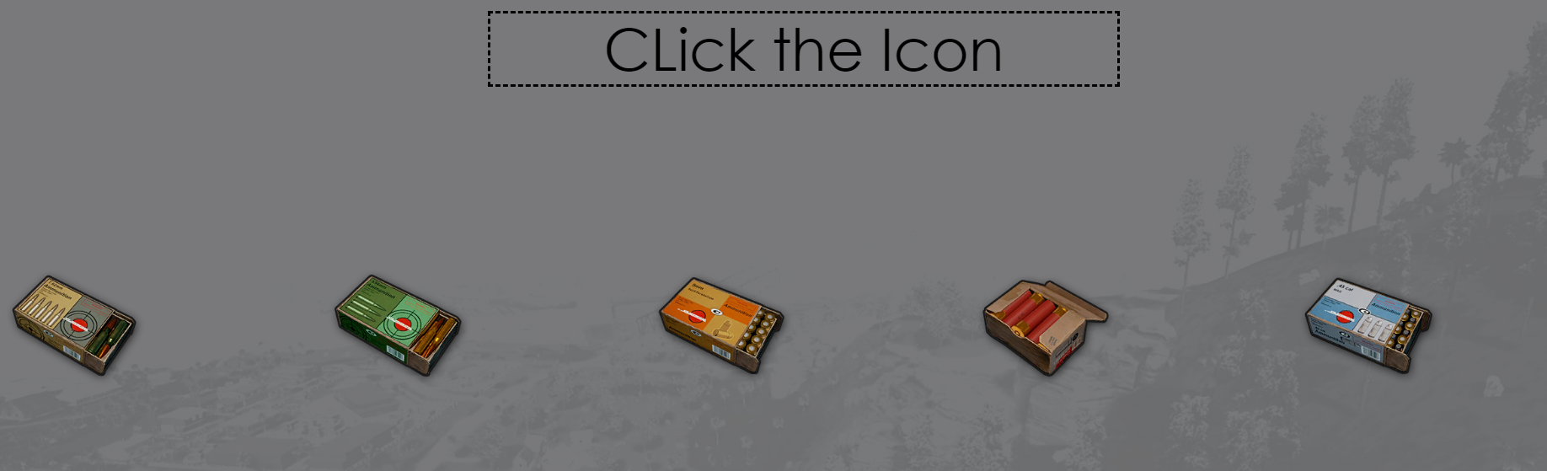

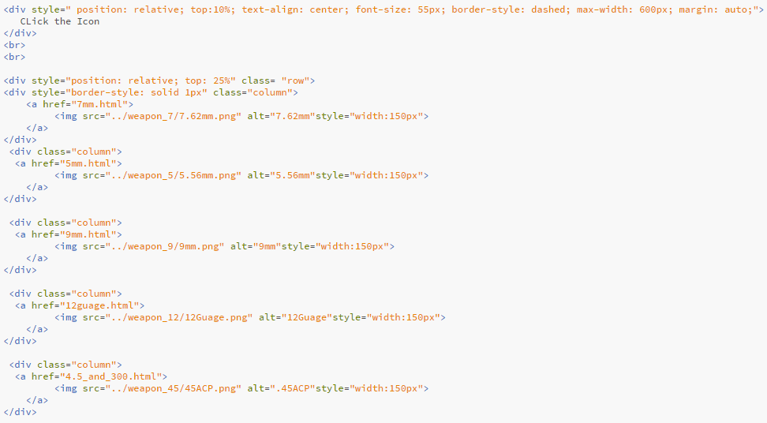

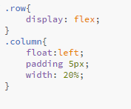

The row and column class makes the 5 icons side by side.

In this way when the icon is clicked the page is linked to the separate html 5 different pages. One of the example is this:

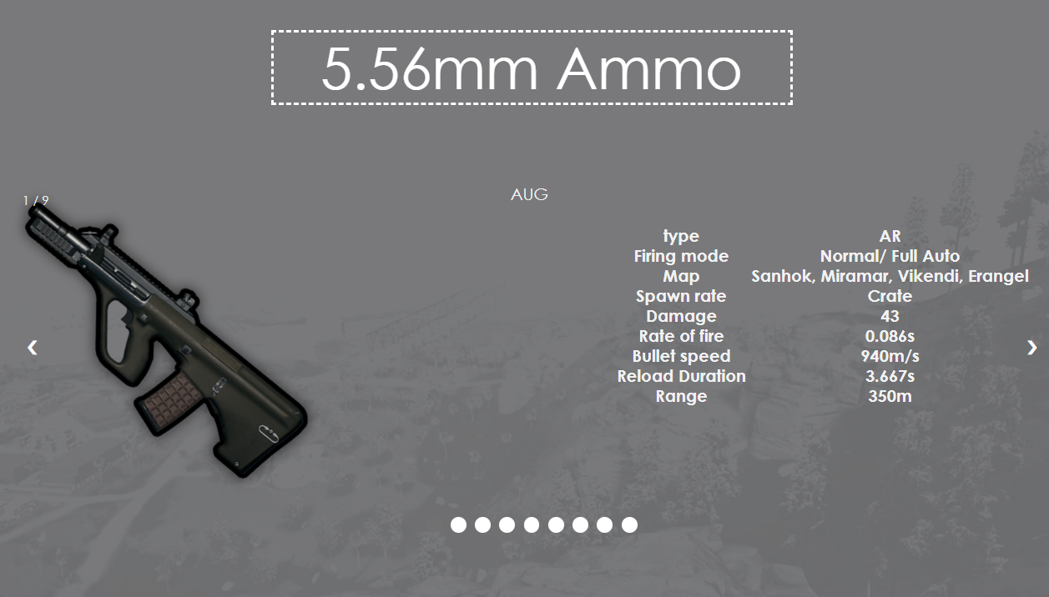

These html pages contain JavaScript, and it makes the image slide effect.

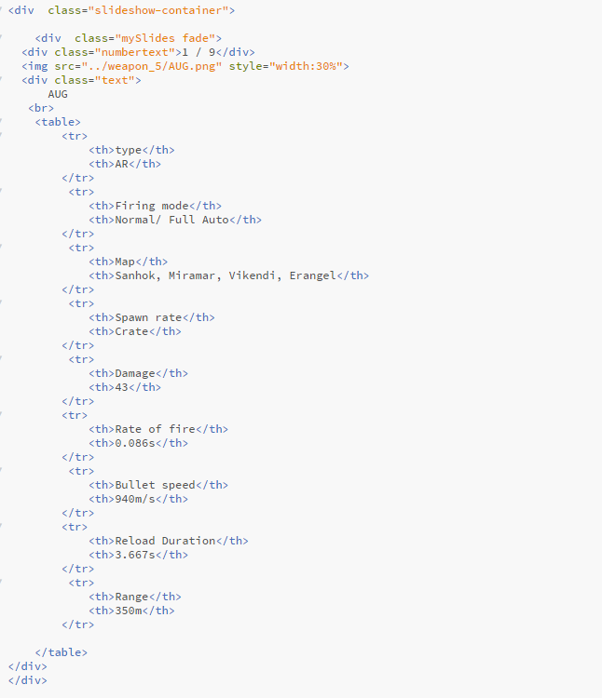

In the f12 key

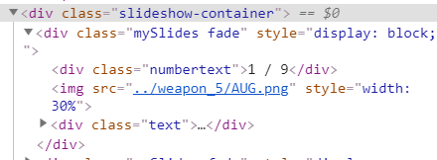

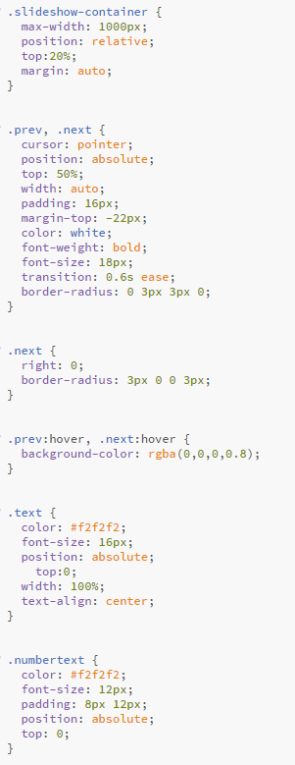

There is <div> class ‘slideshow-container’ at the very big layout. Then there is <div> class’ mySlides’, and ‘fade’. Inside there is ‘numbertext’, image and a table(hidden in class ‘text’).

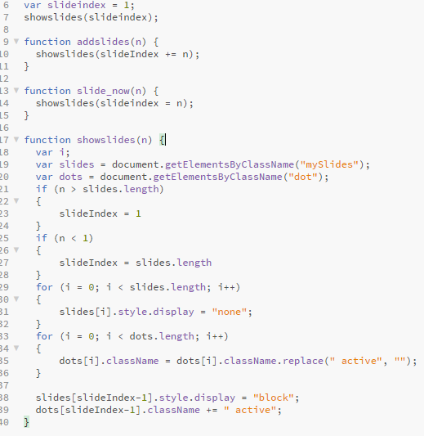

This is the JavaScript that makes the image slide. In the showslides(n) function, by comparing n with the slides.length, the slide is either appears or goes back to the first slide, or goes back to last slide, and the rest of the slides are displayed none. The same goes for the dots making the rest of the dots, that are not the current slide’s dot active.

Using the image slide was a great way of displaying 500 lines of codes. It makes the webpage cleaner, in a way that the user does not need to scroll down the page, for a simple information. Instead simply clicking the next, or the dots allows to access the desired data.

1801550 Cha Seong Kyu

For the group assignment of choice, our group decided to make a website using HTML, JavaScript, and CSS. It was agreed upon to make a website regarding popular video games. In particular this report will cover the making of the website regarding a popular multiplayer online video game, League of Legends. The following document will discuss about the design of the website, information included in it, coding used to make the website, and composition of the website.

The first thing discussed will be the composition of this website.

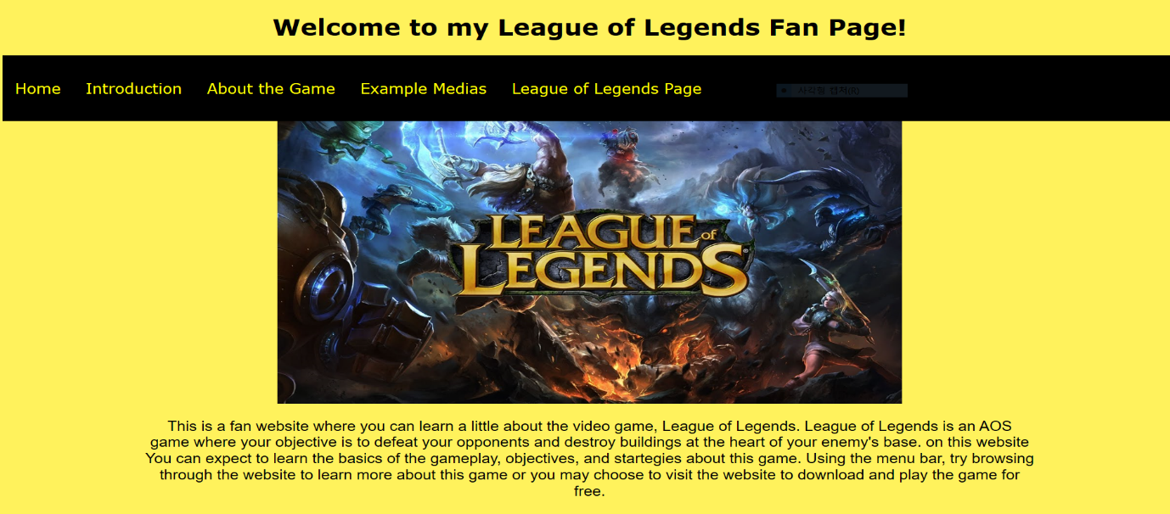All webpage to be described may be accessed by using the navigation bar on top. The following description of website composition describes what’s on navigation bar in order. The home page of the website gives a brief information as the what game League of Legends is. It describes what to expect from the website and the genre of the game. It gives guidance to what the navigation bar is. Above the description is an image of the game’s logo and its characters. The purpose of the image is to pique interest out of visitors who’s new to the game.

The next page after Home is the Introduction page. In this page information regarding League of Legends other than its gameplay are laid out. It talks about its genre, what it’s supported by, what kind of gameplay to expect when playing it, what the concept and general idea behind the lore is, and etc. The general idea of what the game is about is described with its lore. The idea of destroying the enemy’s “nexus” located at the heart of the enemy’s territory and defending your own nexus at the heart of your own territory is described briefly in this page. The general gameplay and how to progress in this game is described too. Above the description is an image of League of Legends icon with some character from the game. Like the image in the Home tab, this image is 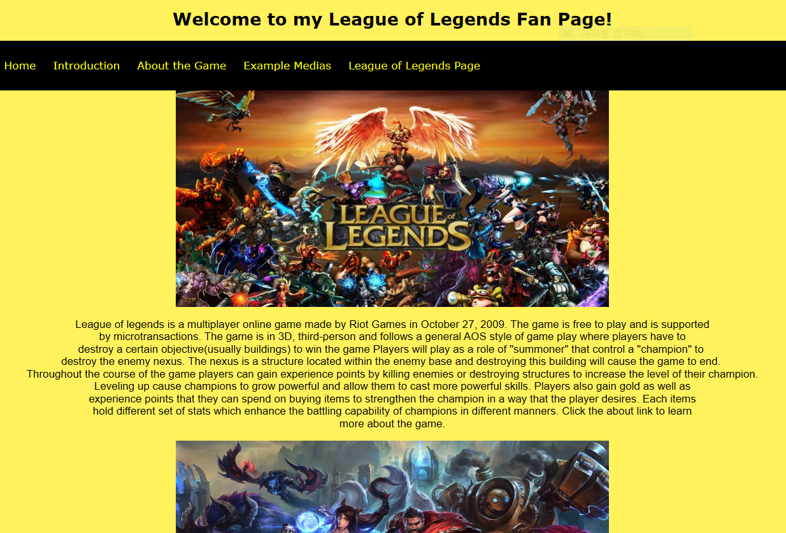supposed to pique the interest of visitors who don’t know what the game is.

The next page is the About the Game tab. It is divided into three sections and the first section describes League of Legends media-wise. As League of Legends is a relatively popular game, a rough statistics and facts relating to the mass media was given to appeal to the visitors who may not know what League of Legends is. League of Legends has millions of monthly players and is ranked to be amongst the most played games around the world. Countries this game proliferated in popularity to are mentioned and a video of cinematics is shown above the description. The cinematics of the game is supposed to give enthusiasm to the people with means more than just an image. The short video doesn’t include the gameplay but it has movie-like representation of characters in the game.

The next section in About the Game tab is the basics tab. Here is where most information about the game lies. This page aims to describe what the game is about in the most basic level. The page describes mainly about the map of the game, shops and characters also known as “champions”, and mechanisms called “summoner spells”, “skills”, and “masteries”. More about this information will be covered when discussing about the information included in the website.

The next and also the last section of the page is Gameplay tab. This page has list of terminologies within League of Legends, In-depth information about basic gameplay. This page holds advanced information about progression of the game.

The next and last content of this website is the Example Medias page. This page has videos and a link of medias other than the game itself. Comics, trailer videos, and the official Youtube channel of League of Legends are displayed for visitors of the page to spectate as they please. The link next to example medias lead to the official League of Legends page. This link is present so as to make visiting the website readily available.

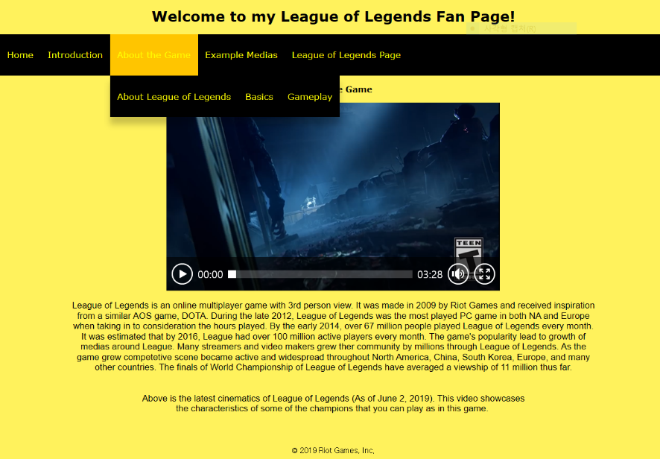

Regarding the design of this page, League of Legends has a color scheme of blue, yellow and black. This website follows the same color schematics. The background color is yellow so as to give a bright appeal while the texts and images chosen were black or blueish. At the top of the webpage is a text “Welcome to my League of Legends Fan Page!” to remind visitors what this website is no matter what page they’re at. Below that is a navigation bar to allow easy visiting of different pages. The navigation bar has pages ordered so that visitors would visit each page in the ordered manner. At the end of the navigation bar is the link to League of Legends official website. It is there so that people whose visited the site can easily visit the website if they wish to play the game or read more about it. Images and videos to act as a reference are shown before explanation to aid understanding. Methods used to show images involves slideshows and image galleries.

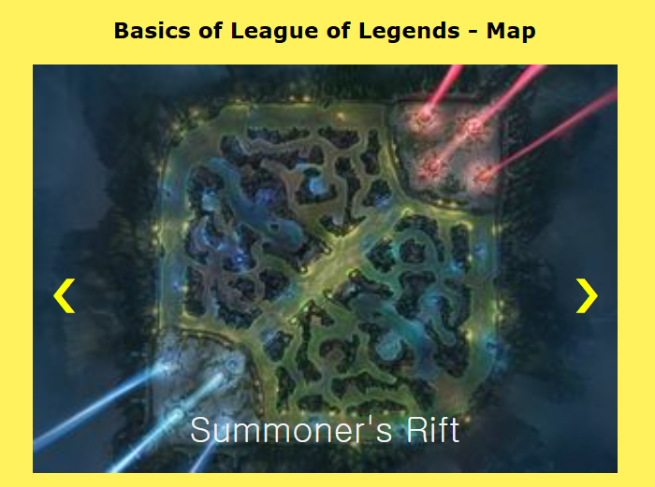 Information included in each page are all thoroughly explained except the Basic and Gameplay tab under the About the Game section. In the Basic tab the key objects and areas of the map of League of Legends is described with a slideshow. Below the slideshow is an explanation of what each object are and what they do. For every terminology is an image included in the slideshow to aid the understanding. The slideshow shows zoomed in image of what the objects 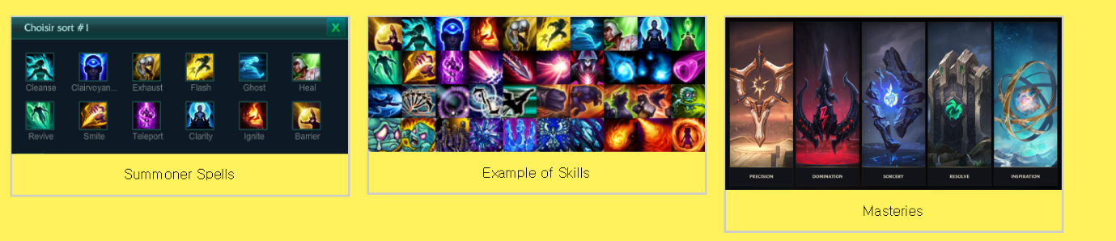are and any reader of the website may follow the explanation of what it is.

Below the description of the map is a description of shops and champions. Champions are playable character that players assume the role of when playing the game. Shop is a mean of progressing the game. Images giving players a general idea of what they both look like are shown. Lastly, below all aforementioned information is an explanation of what summoner spells, skills, and masteries are. These are key components of the game a player must be familiar with in order to play the game proficiently. Image galleries of these game mechanisms are present and they can be clicked for a closer look on a separate page.

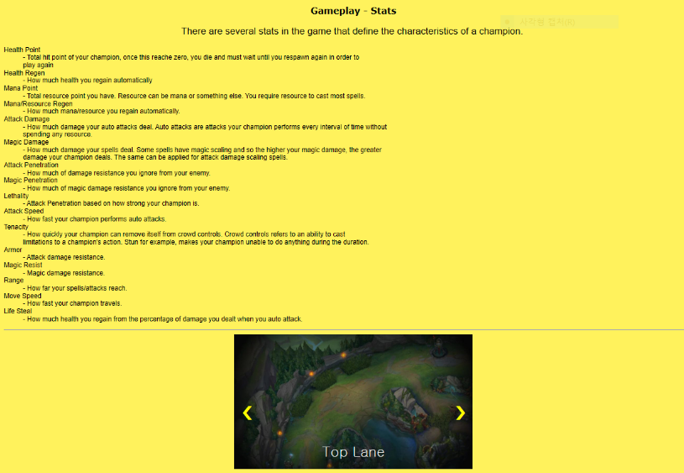 The next page with an in-depth explanation is the Gameplay page. It has descriptions of many terminologies that have to do with the game. Stats for one, are what define a champion and their traits. Below description of stats are in-depth explanation of what lanes and roles are. This 5 in one team multiplayer game separates the role of each players by separating the initial playing position of players. This fact is delved upon with greater detail on this page. Below that explanation are many commonly used terminologies in League of Legends that one may hear or see being used while playing the game or when spectating medias that has to do with the game.

Codes used for this website are JavaScript, CSS, and HTML. HTML was used to make the texts, thematic break, place images and videos in the page. It served as the basic endoskeleton of this site. Paragraphs were all written in <pre>tags so as to maintain line breaks and spaces without having to include <br> tag for every line breaks. Images and videos were posted with <a href> tag 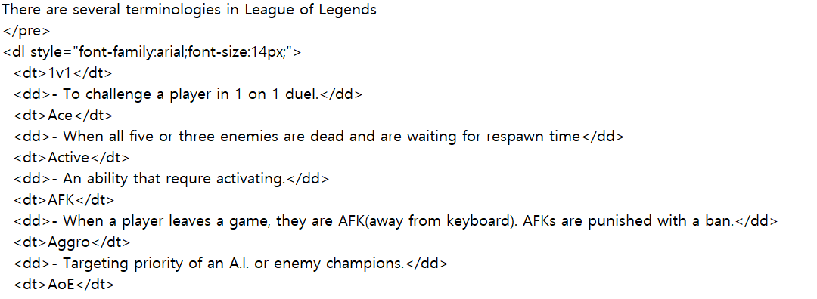linking to the original source of the image. These were given alternate tags so that if an image were to not show up, a text will replace the image. In the Gameplay webpage bullet points, multi bullet point in particular was used to present unordered list of information. <div> class was used to separate the formatting of different components of the website. Namely the image gallery, navigation bar, slideshow, and the text included in the paragraph were separated by div with different class attached to it.

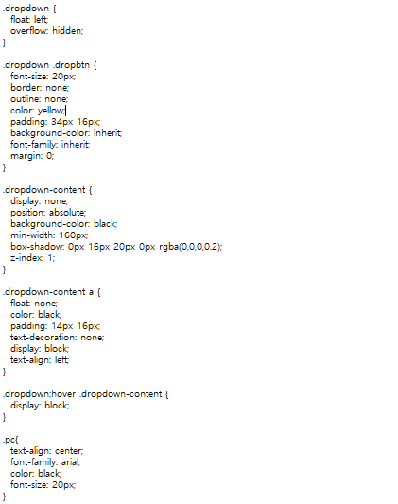

CSS was used for formatting all texts, images, and videos. It was used to format the navigation bar into its current state. The image to the left of this text shows what was used to format the dropdown menu of this page. The drop-down menu is intended to be divide the menu in the navigation bar into smaller sections so that pages can be divided into smaller units. The pc class is what defined the text written in the main body of the page. Image galleries were each defined with specific width and height. They are placed with <a href> tag so that visitors can click on the image to look at the image with greater zoom. Arrows in the slideshow that may be used to navigate through the slideshow has a fade animation. This adds another depth to the slideshow. Rather than a still colored arrow, the buttons are transparent until a mouse hovers over it. JavaScript was used to make the slideshow of this website possible. Slides were assigned “I” values and using the for loop, slides were made so that once the slide reaches the end, the slides will start again from the start.

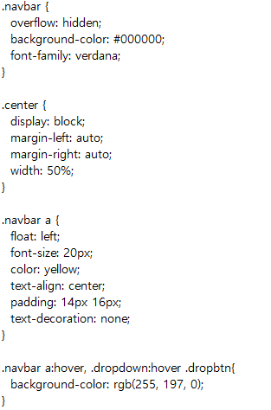To the left is a class that defines the navigation bar. Each button was made so that buttons will automatically align themselves from the left. Paddings, text-align were given to resize the buttons in desired manner. When hovered, navigation bar has color change when hovered over. The center class is used to place image or videos at the center of the website (the website floats image or website to the left as default). Text decoration of the buttons were set to none so that the texts in navigation bar will not be decorated to anything.

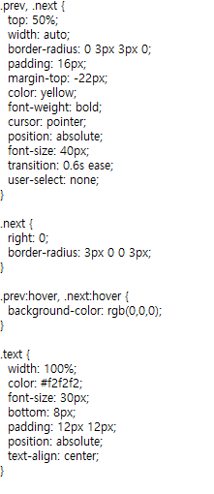

The coding to the left describes the cursors used for moving around the slideshow. Next and prev class indicates both pointers used on the slideshow. Animation time and what animation to play are defined in this class as well. Text is the text on the image galleries. The paddings are given to space the image and texts itself. Position is absolute so that it will stay below image galleries.

That concludes the general explanation of composition of the website, information in the website, coding used to make it, and design theory involved behind it. Each component define this website in parts. The making of this website was inspired by “wikia” pages dedicated to serving as wiki page of video games.

Muyoung Kim

Group 10

Our team created the homepage using HTML, CSS, Javascript. The theme of our team was to make a homepage for the game and introduce it. The three games are Battleground, League of Legends and Starcraft, respectively, and I chose StarCraft on them. Now I will explain the StarCraft homepage that I made.

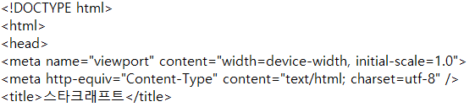

Once the

<meta name=”viewport” content=”width=device-width, initial-scale=1.0”>

is inserted in the first part of each page, the ratio can be implemented properly on the mobile phone.

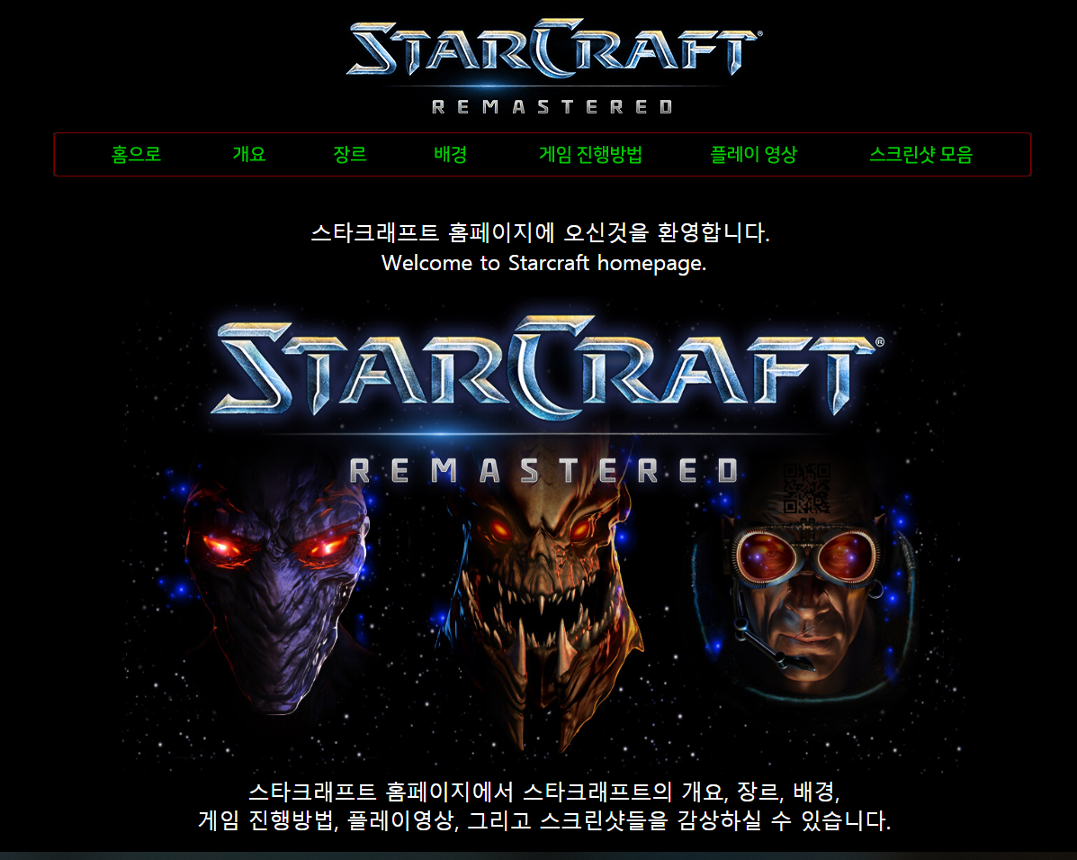

This picture is a home screen. You can see the home screen by clicking the index page first. There is a StarCraft logo on the top and a status bar under each of them. Each item is divided into outline, genre, background, how to play, play video, and screen shot. You can click to go to the page you want. Below it, I inserted the main picture and inserted a simple phrase.

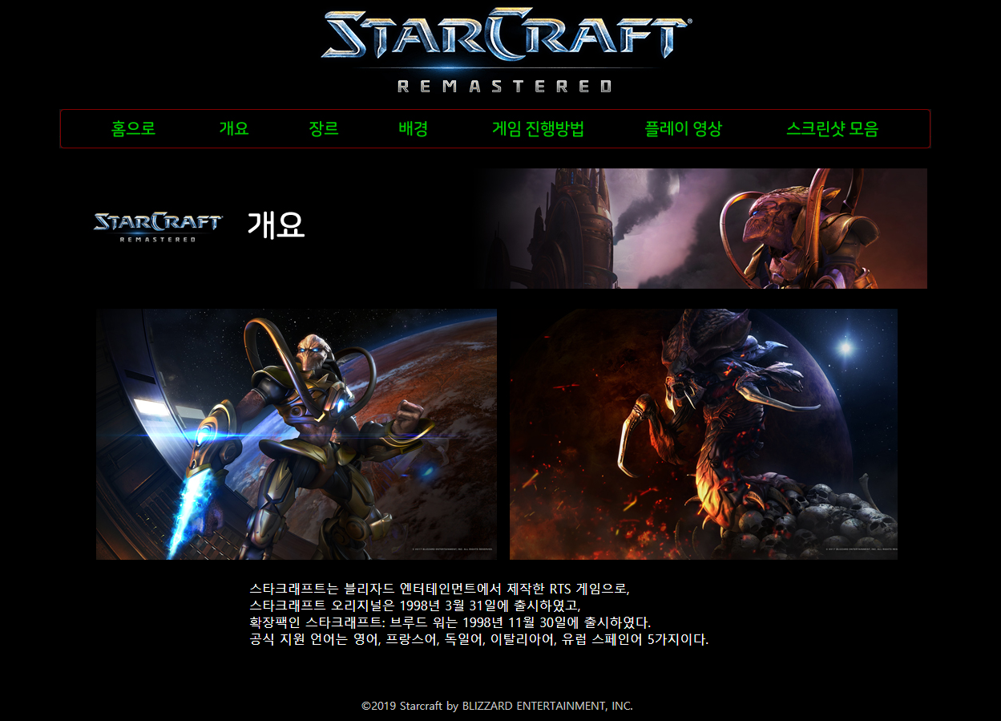

The second is the Overview tab. The Overview tab explained what StarCraft was, what it was, when it was released, and what language it supported. StarCraft is a game developed by Blizzard Entertainment, and an expansion pack has been released and officially supports five languages.

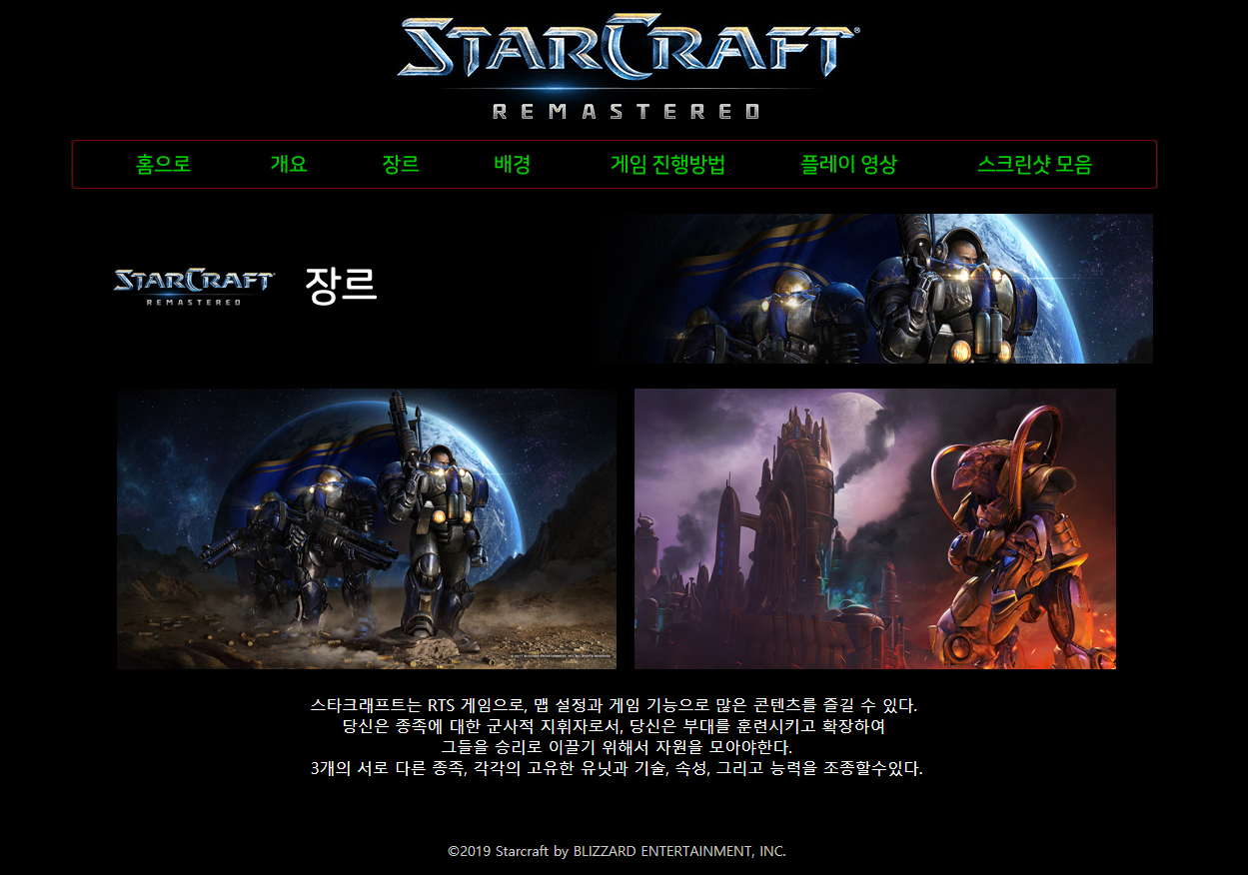

The third is Genre. The Genre tab briefly describes what kind of genre this game is going to be based on, and the description of the three races is simple. Starcraft is a Real Time Strategy (RTS) game that draws one of three races, collects resources, trains units, and wipes out opponents using their own unique units and skills.

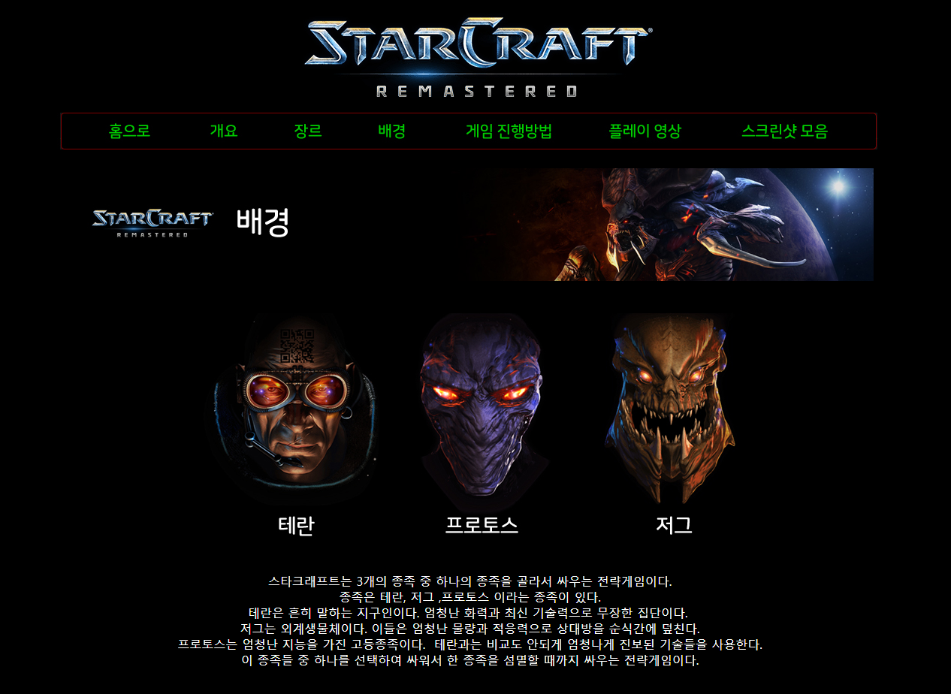

The fourth is Background. The Background tab details the game's story background and three races. Here you can see the characteristics of each species. The three races of Starcraft can be divided into terran, zerg, and protoss respectively. Terran is an Earthling and has a great firepower and skill. Zerg are extraterrestrial organisms and they are a species of great quantity with great fertility. Protoss is a highly intelligent higher tribe. It is a race that annihilates opponents by using more advanced technology than terran. You must choose one of these three races to fight.

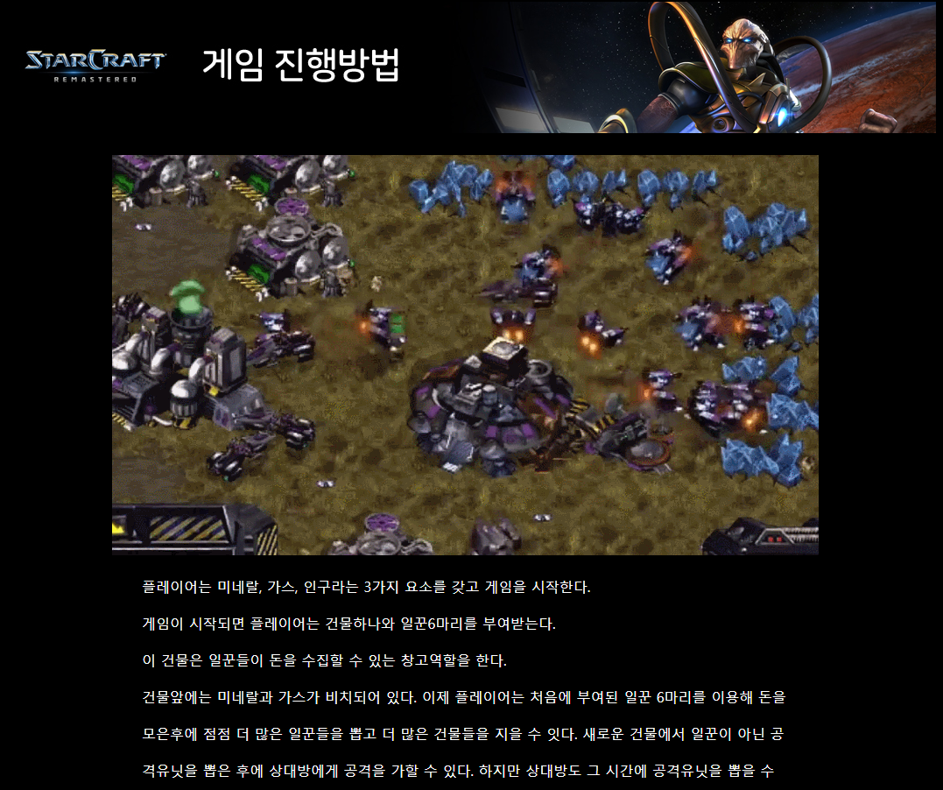

The fifth is How to play. It is described in detail how to play in earnest. Collect resources, collect advanced units, defeat enemies, and describe the magical units. When the game starts, the player starts the game with three elements: minerals, gas, and population. When the game starts, the player receives one building and six laborers. Main building serves as a warehouse where workers can collect money. Mineral and gas are in front of the building. Now the player can collect more money with the first 6 laborers and then build more and more buildings and build more buildings. You can attack an opponent after drawing a non-worker attack unit from a new building. However, it will be an easy attack because the opponent can draw an attacking unit at that time. Players can choose not only an attacking unit, but also a magic unit that can intelligently craft a strategy. Magic units are units that are optimized for intelligent play rather than attack. For example, you can make a momentary move, lightning strike, or poison your opponent. Use these units to defeat all of your opponent's buildings and win the game.

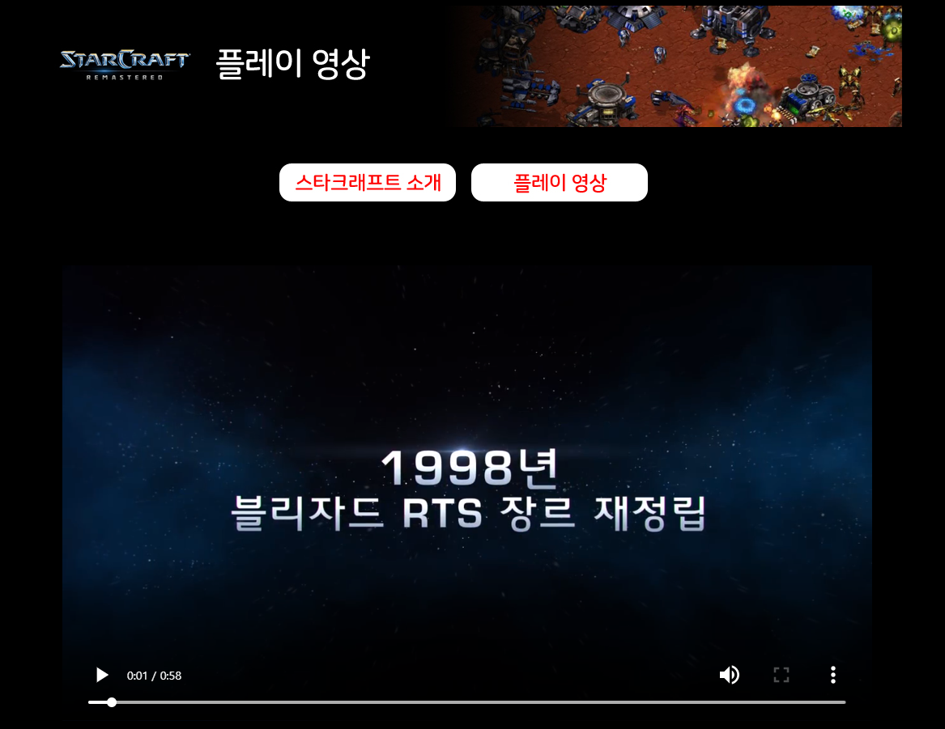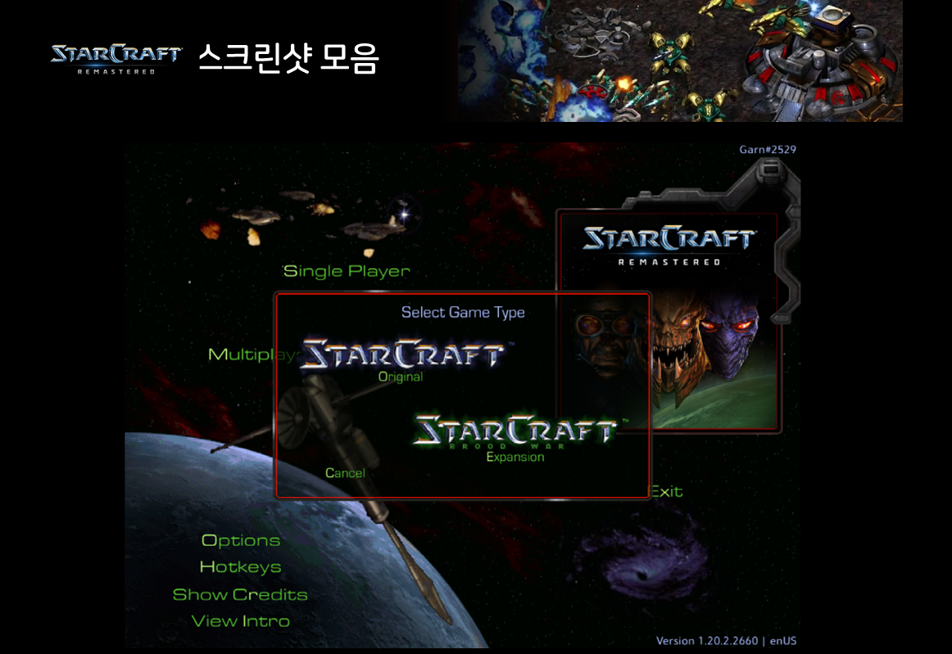

The sixth and The seventh are Video and Screenshots. Starcraft introductions, videos and images are included. You can see videos and screenshots when you want to see anytime.

Now I’ll explain about code of my Starcraft Webpage. I made this webpage using HTML, and CSS. I used HTML to insert text, video, image, and navigation bars and I used CSS for font-style, font-size, font-color and background color.

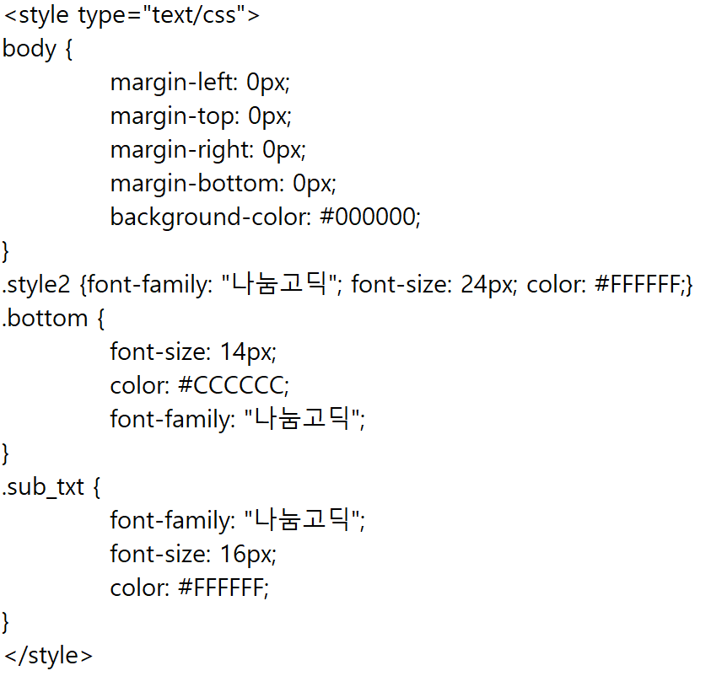

The margin was set to 0px and the background color was set to black using # 000000 to match the mood of the game. font used the sharing gothic which seemed to be the most suitable, size was 24px, and color was adjusted to #FFFFFF white. Other parts used the right color and size.



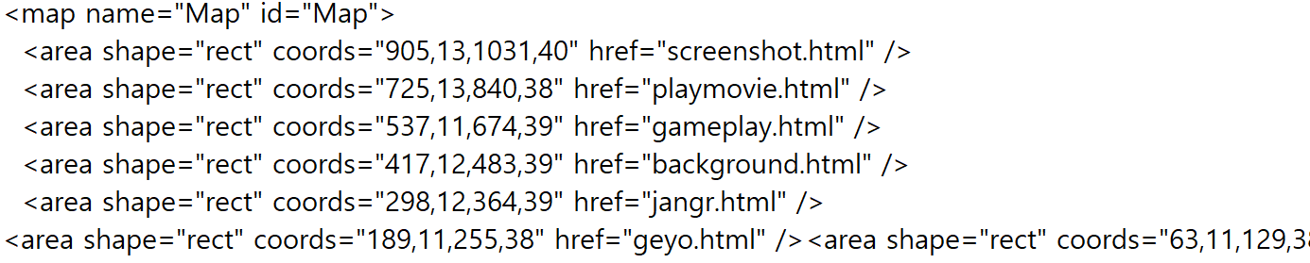

I image the navigation bars and then use Map to mark each section with coordinates. So if you click on the specified area, you can move to each item.

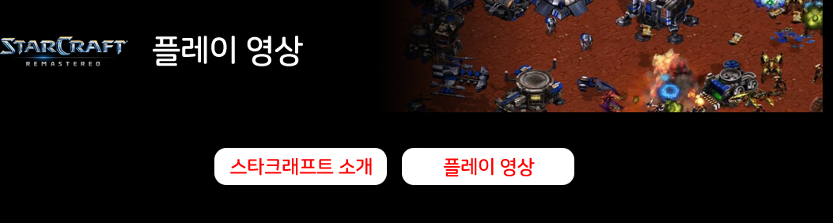

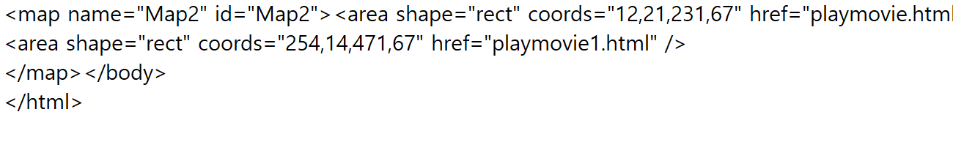

Because there are two different styles of video in the play video, I divided them into two. One is StarCraft Introduction and one is gameplay video. In this example, Map2 is used to display the coordinates of each zone, and click to move to the item.

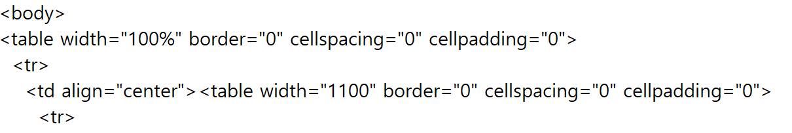

In the body, I adjusted the value of the table like this, So I make the neat and clearly view.